Article Type
TITLE OF THE MANUSCRIPT (Times New Roman, 12 Caps, Left, Bold)
Author Name 1*, Author Name 2, Author Name 3 (Times New Roman, 10, Left, Bold)
¹Department, College Name, Email ID (Times New Roman, 8, Left)
²Department, College Name, Email ID (Times New Roman, 8, Left)
³Department, College Name, Email ID (Times New Roman, 8, Left)

ABSTRACT
a) The number of words in an abstract should be between 200 to 400 words for research paper and between 150 to 300 words for review paper.
b) The abstract should be in paragraph format.
c) There should not be any reference citations or unspecified abbreviations in the abstract.
d) The abstract should give clear idea about the main objective of the study.
Keywords | The author should mention four to six keywords separated by semicolon “;”. The keywords are used for proper indexing of the manuscript
Article Info | Received: xx-xx-xxxx | Revised: xx-xx-xxxx | Accepted: xx-xx-xxxx | Published: xx-xx-xxxx

1. Introduction
Journal of Computer Applications and Electrical Engineering Methodologies strives to create an online platform to discuss and share knowledge and ideas that are upcoming and latest in the field of Computer Applications and Electrical Engineering.
1.1 Manuscript Submission
The manuscript must be submitted online through the online paper submission portal. The paper to be submitted must be original and should not be under consideration for publication in any other journal.
1.2 Length of the Manuscript
The preferable length of the manuscript is between 6-14 pages including the figures and the tables.
1.3 Manuscript Template
1.3.1 Title
The title should be clear and concise. It should relate to the concept conveyed in the manuscript.
1.3.2 Author Information
The complete author details should have the following details,
- The names of the author along with the affiliations
- Affiliation here means name of the Institution, Department, City, State, Country
- In case of only two authors, use “and” to separate the author names
- In case of authors more than two, use comma “,” to separate the author names and use “and” between the names of last two authors
- The email id of the corresponding author. It may be either institutional or personal email id
- The Orcid id of the author, if available
A superscript “*” should be used to mark the corresponding author and superscripts such as 1, 2, 3… should be used to mark the author positions
2. Abstract
The number of words in an abstract should be between 200 to 400 words for research paper and between 150 to 300 words for review paper. The abstract should be in paragraph format. There should not be any reference citations or unspecified abbreviations in the abstract.
3. Keywords
The author should mention four to six keywords separated by semicolon “;”. The keywords are used for proper indexing of the manuscript
4. Format of the Manuscript
The authors are requested to submit the manuscript in an editable format including the figures and the tables preferably in .docx format.
The template of the manuscript can be downloaded from the following link (mention link of the template document)
Table 1: Formatting Details
 | Readings
Page Layout | Margins  Top, Bottom: 2 cm  Left, Right: 2 cm  Paper Size: A4  Header, Footer: 1.27 cm
Heading 1 | Sample: I. Introduction  Font Size: 11 (Bold)  Alignment: Left
Sub Heading 1 | Sample: 1.1 Length of the Manuscript  Font Size: 10 (Bold)  Alignment: Left
Sub Heading 2 | Sample: 1.2.1 Title  Font Size: 9 (Italic)  Alignment: Left
Paragraph 1 | Font Size: 9  Alignment: Justify
Table , Figure Caption | Font Size: 9  Alignment: Center
Table Content | Font Size: 8  Alignment: Justify
References | Font Size: 8  Alignment: Justify
5. Abbreviations
The full form of the abbreviations should be mentioned when used for the first time.
6. Acknowledgement
Acknowledgement to people, funding agency, grants etc. should be mentioned separately in the acknowledgement section.
7. References
All the references used in the preparation of the manuscript should be cited properly in the order of usage of the reference. The references should be mentioned at the end of the manuscript with proper numbers. The reference number should be included inside square brackets with left alignment. The doi of the article can be included in the reference, if available.
8. Publication Ethics
JCAEEM follows certain publication ethics to maintain the quality and to ensure the publication of standard original research work. The publication ethics of the journal is based on the guidelines formulated by COPE.
8.1 Examination of Articles
All the submitted manuscripts undergo initial technical check that examines the manuscript’s adherence to the journal template. Upon passing the technical checkup, the manuscripts are then peer reviewed by reviewers with technical expertise. Our team may also seek the advice of persons outside the review team, if and when necessary. The outcome of the review process may be Acceptance/Acceptance with major revisions/Acceptance with minor revisions/Rejection with resubmission/Rejection.

8.2 Plagiarism
JCAEEM follows Turnitin based plagiarism report to check the amount of plagiarism in the submitted manuscript.
8.3 Text Recycling/ Self Plagiarism
Authors may sometime use concepts or phrases from their own previous work which may lead to Self-Plagiarism / Text Recycling. In such case, the authors are advised to follow the guidelines as mentioned by COPE in https://publicationethics.org/resources/guidelines/text-recycling-guidelines-editors to solve the issue.
Repetition of work either as a part or a whole is highly unacceptable and the manuscript will be rejected without any review process.
8.4. Review Process
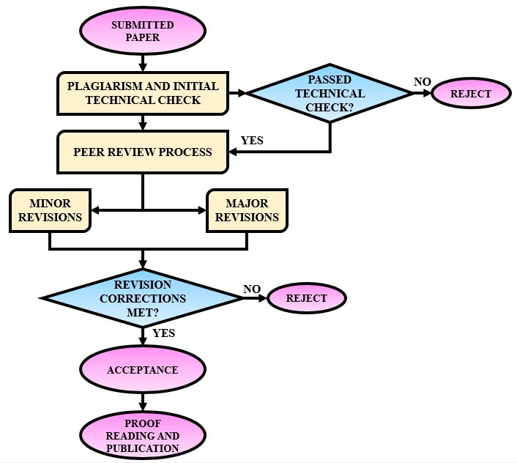
Figure 1: Review Process
8.5 Copyright
A copyright transfer form has to be signed by all the authors and should be submitted along with the final manuscript after the acceptance. This is to prevent any other person from claiming the work in future.
8.6 Conflict of Interest
The authors should declare any conflict of interest if present in the work during the submission of the manuscript. This is to enable the transparency about any work that directly or indirectly influence the submitted research work.
References
- A. A. Author 1, B. Author 2, C. Author 3. Paper Title, Journal Title, vol: XX, no: XX, pp: XX-XX, Year.
- A. A. Author 1, B. Author 2, C. Author 3. Paper Title, Journal Title, vol: XX, no: XX, pp: XX-XX, Year.
- A. A. Author 1, B. Author 2, C. Author 3. Paper Title, Journal Title, vol: XX, no: XX, pp: XX-XX, Year.
- A. A. Author 1, B. Author 2, C. Author 3. Paper Title, Journal Title, vol: XX, no: XX, pp: XX-XX, Year.
- A. A. Author 1, B. Author 2, C. Author 3. Paper Title, Journal Title, vol: XX, no: XX, pp: XX-XX, Year.

